Sanjivani University
Artificial Intelligence and Data Science

DevOps Unit 1 Mini Project
Enterprise Student Record and Academic Management Platform
(Unit 1: Product Engineering & Design Thinking)

Name: Sakhee Balasaheb Sonawane
PRN: 2125UDSF1011

1. Introduction to Software Product Development
The Enterprise Student Record and Academic Management Platform is planned as a structured software product for higher-education institutions. The project follows a complete product-engineering lifecycle rather than beginning directly with coding. The planning process covers domain understanding, user-centered design, requirements, architecture, product vision, MVP, and roadmap.

1.1 Comparative Analysis: Programming vs. Software Product Engineering
Dimension | Programming / Coding | Software Product Engineering
Primary Goal | Write executable code and implement logic. | Build a useful, maintainable, and scalable academic system.
Scope | Functions, classes, or individual programs. | Full lifecycle: requirements, UX, architecture, testing and delivery.
Success Metric | Code works for test inputs. | User adoption, reliability, usability, and business outcomes.
Mindset | Technology-centric: How do I implement it? | Product-centric: What academic problem are we solving?

1.2 Root Causes of Software Project Failures
- Misaligned requirements: features may not match actual student/faculty needs.
- Technology-centric bias: selecting tools before understanding the academic problem.
- Communication silos: gaps between academic users, developers, and operations.
- Lack of iterative feedback: problems are discovered too late if users are not involved early.

Visual Section: System Development Lifecycle
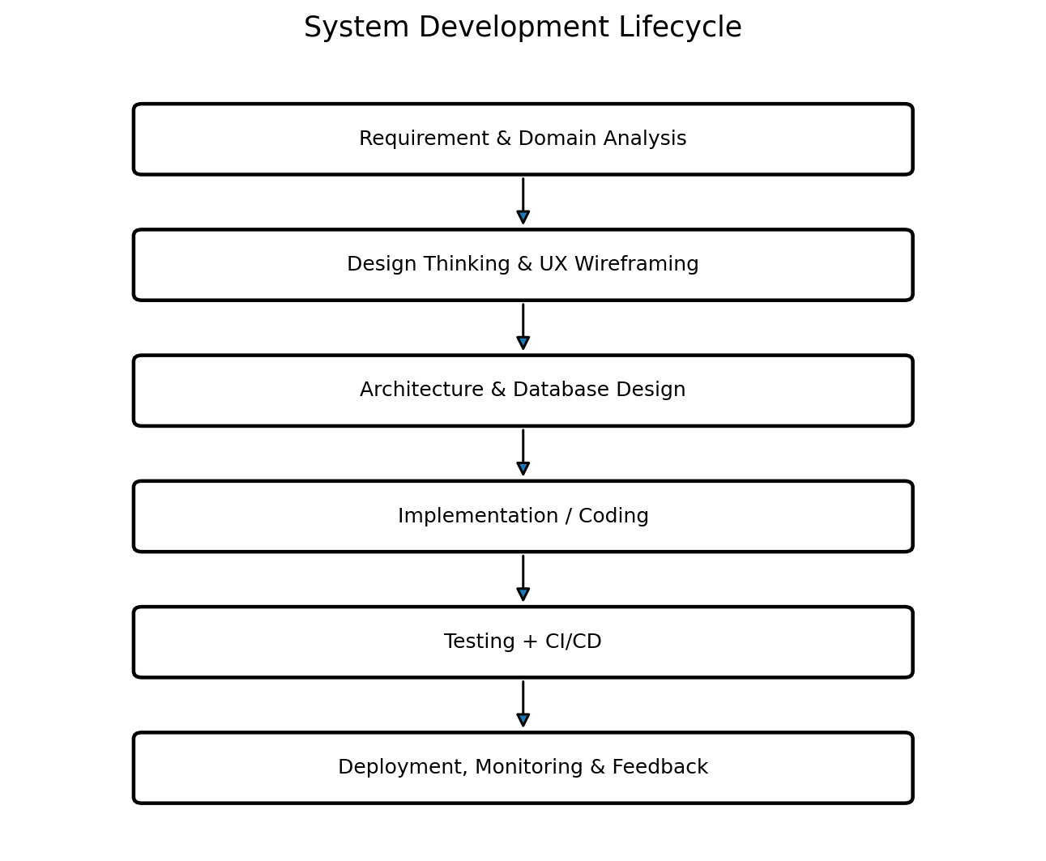

2. Business Understanding: Education & Academic Services
Before implementation, engineers must understand the academic operations supported by the proposed platform.
- Student admission and registration.
- Course registration and academic record management.
- Attendance recording and monitoring.
- Examination and result management.
- Academic and administrative report generation.

2.1 Manual Process Challenges vs. Automated Software Solutions
Manual Operational Bottleneck | Automated Platform Solution | Business Outcome
Scattered student records | Centralized digital student database | Faster retrieval and improved consistency
Paper/manual attendance | Digital attendance module | Simpler monitoring and reporting
Manual result preparation | Structured examination/result module | Reduced calculation and reporting errors
Paper-based reports | Automated report generation | Faster administrative decision-making

3. Introduction to Design Thinking
Design Thinking is an iterative, human-centered problem-solving approach. It places user needs and real-world academic workflows before technical implementation.
- Human-centered innovation
- Creative problem-solving and ideation
- Iterative prototyping and early validation

4. Applying the Five Stages of Design Thinking
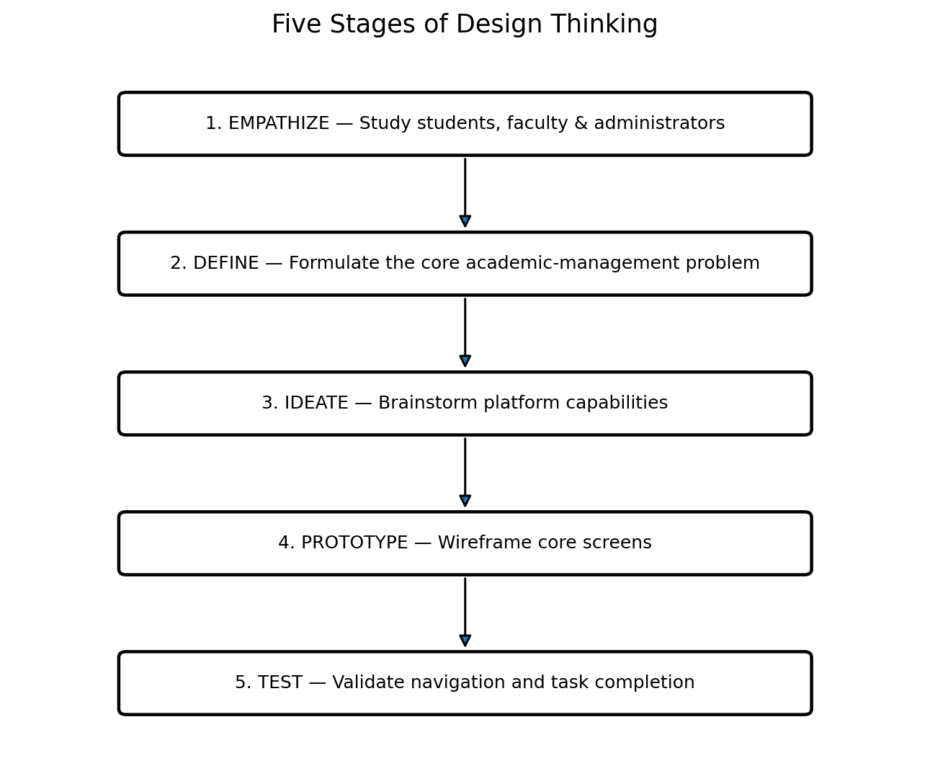

Stage 1: Empathize
Study students, faculty members, academic administrators, examination staff, and IT support to understand their daily tasks, frustrations, and expectations.

Stage 2: Define
Core problem statement: "Students, faculty and academic administrators need a centralized, reliable and easy-to-use platform for managing student records, attendance, examinations and results because fragmented/manual processes can cause delays, errors and limited visibility."

Stage 3: Ideate
High-value ideas include a centralized student profile, attendance dashboard, examination/result module, role-based access, and automated academic reports.

Stage 4: Prototype
Prepare low-fidelity wireframes for Login, Student Dashboard, Faculty Dashboard, Administrator Dashboard, and Academic Report screens.

Stage 5: Test
Demonstrate prototypes to representative users, observe navigation and task completion, collect feedback, and revise the design before full engineering.

5. Enterprise Application of IBM Design Thinking
The project applies three IBM Design Thinking principles.
Pillar | Application to Student Record Platform
Focus on User Outcomes | Measure whether users can access records, attendance, and results easily and complete academic tasks efficiently.
Restless Reinvention | Continuously improve screens, workflows, and performance using feedback and observed usage.
Diverse Empowered Teams | Coordinate product, UX, development, QA, database and operations perspectives.

6. The IBM Loop Engine
The platform follows the continuous Observe → Reflect → Make cycle.
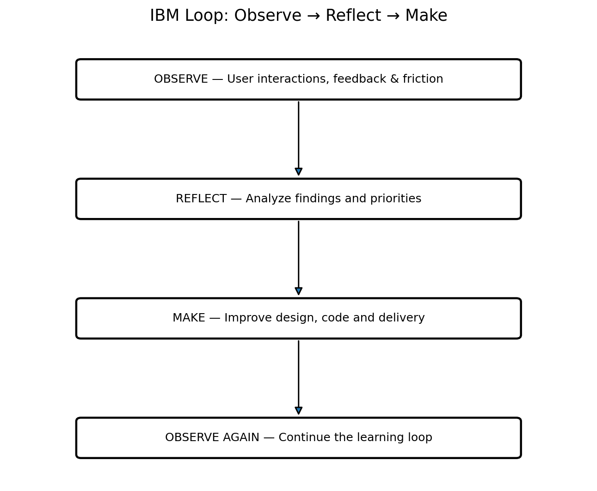

7. Stakeholder User Personas
User Persona | Primary Objectives | Key Frustrations / Pain Points | Target Platform Feature
Aarav (Student) | Access academic records and results quickly. | Multiple sources, unclear status and delayed information. | Student portal, academic dashboard and reports.
Priya (Faculty) | Record attendance and academic information efficiently. | Manual entry and repetitive record maintenance. | Faculty dashboard and attendance module.
Dr. Verma (Administrator) | Monitor academic operations and generate reports. | Limited centralized visibility and manual reporting. | Executive dashboard and report generation.

8. Stakeholder Matrix
Stakeholder Group | Key Roles | Responsibilities & Project Expectations
Business / Academic Stakeholders | College Management, Academic Admin, Students, Faculty | Define academic goals, validate usability and ensure process alignment.
Engineering Stakeholders | Developers, UI/UX Designers, QA Engineers | Design architecture, build interfaces and verify quality.
Operations Stakeholders | IT Support, Database Administrators, Security | Maintain infrastructure, database integrity, access control and reliability.

9. Requirements Engineering Specification

9.1 Functional Requirements (FRS)
- Authentication: role-based access for Student, Faculty, Administrator and Examination Cell.
- Student Registration: create, update and manage student profiles.
- Academic Records: manage course and academic information.
- Attendance Management: record and view attendance.
- Examination & Results: store examination information and manage results.
- Report Generation: generate academic and administrative reports.

9.2 Non-Functional Requirements (NFRS)
- Security: authentication, authorization and protected academic data.
- Usability: simple, responsive and understandable interface.
- Reliability: consistent records and dependable operation.
- Scalability: support growth in users and academic records.
- Maintainability: modular structure and clear separation of responsibilities.

10. Product Vision & Minimum Viable Product (MVP) Scope

Product Vision Statement
“To deliver a modern, centralized and user-friendly Student Record and Academic Management Platform that simplifies academic record handling, improves access to information, and supports reliable administrative reporting.”

MVP Release Scope
MVP Capability | Purpose
User Login & Role-Based Profile | Provide secure access based on user role.
Student Record Management | Maintain core student information.
Attendance Management | Record and view attendance.
Examination & Result Management | Manage academic examination and result information.
Academic Report Generation | Produce useful academic and administrative reports.

11. Enterprise Engineering Roadmap
Phase | Main Activities
Phase 1: Domain Analysis | Understand academic workflows, users and pain points.
Phase 2: Design Thinking & Prototyping | Empathize, define, ideate, prototype and test.
Phase 3: Agile Sprint Planning | Convert validated needs into backlog items and milestones.
Phase 4: Core Application Development | Build frontend, backend, database and academic modules.
Phase 5: DevOps Automation | Testing, CI/CD and deployment automation.
Phase 6: Infrastructure Automation | Environment configuration and infrastructure management.
Phase 7: Production & Monitoring | Deploy, observe usage and continuously improve.

12. System Architecture & Repository Structure

12.1 Initial System Architecture
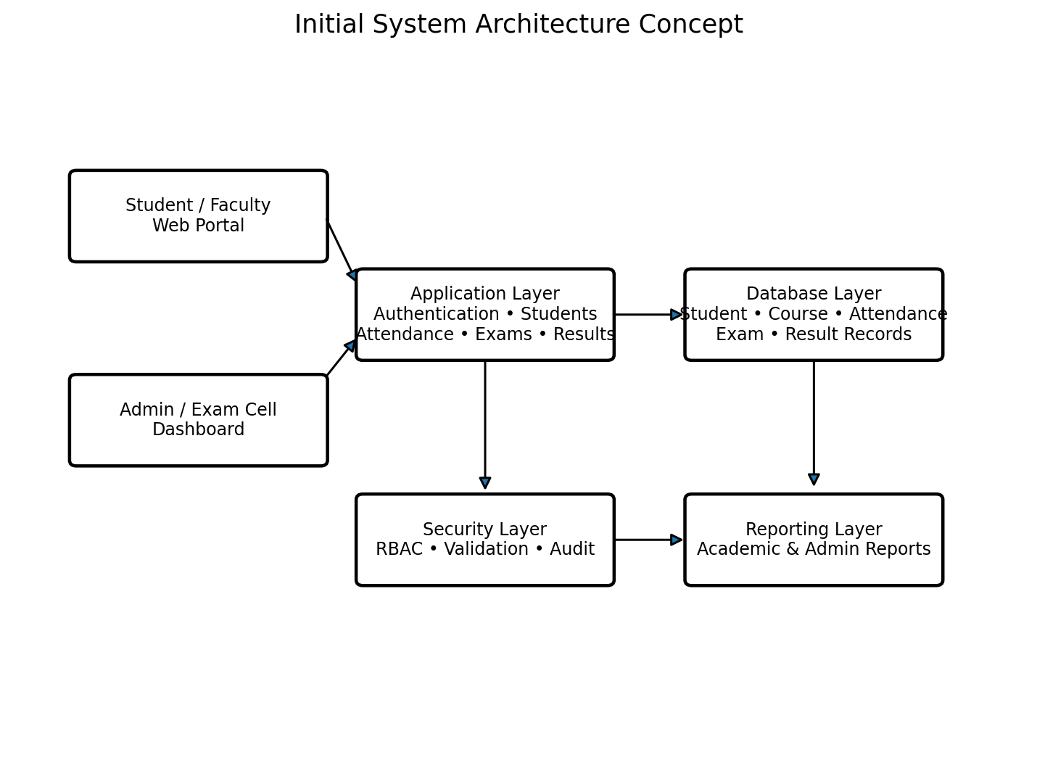

12.2 Repository Hierarchy
student-record-academic-platform/
├── .github/ # CI/CD workflows
├── app/ # Application source code
│ ├── modules/ # Students, attendance, exams, results
│ ├── database/ # Schemas, migrations and models
│ └── tests/ # Unit and integration tests
├── docs/ # Architecture & requirement documents
├── frontend/ # User interface
├── backend/ # Application/API layer
├── deployment/ # Deployment configuration
└── README.md # Setup and onboarding instructions

13. Trainer / Student Execution Deliverables Checklist
- Business Problem Statement & Business Justification Report
- Product Vision Statement & MVP Feature Matrix
- Stakeholder Responsibility Matrix & User Persona Profiles
- Functional Requirements Specification (FRS)
- Non-Functional Requirements Specification (NFRS)
- Design Thinking Report
- IBM Design Thinking & IBM Loop Documentation
- Multi-Phase Product Engineering Roadmap
- Initial System Architecture Diagram
- Initialized Git Repository & Standardized Folder Architecture

14. Conclusion
This Unit-1 project establishes a complete product-planning foundation for an Enterprise Student Record and Academic Management Platform. It converts the academic problem into a user-centered product definition with stakeholders, personas, requirements, MVP, roadmap and architecture. The documentation is intended to support Agile planning and later implementation.

